# Perforce Install and Setup Guide (Windows)

Written By: Justin Murphy

This document is to assist with installing and setting up perforce for use with the Final Project version control server. Please refer to the additional resources for how to use perforce.

## Part 1: Install

1. Go the perforce download page: <http://www.perforce.com/downloads/complete_list>.
2. Select Windows for the platform and either x86 or x64 for OS this must match the version of windows you have installed.
   1. If you don’t know what version you have open up your start menu right click computer and select properties, under the property System type it will say either 64-bit operating system (x64) or 32-bit operating system (x86).

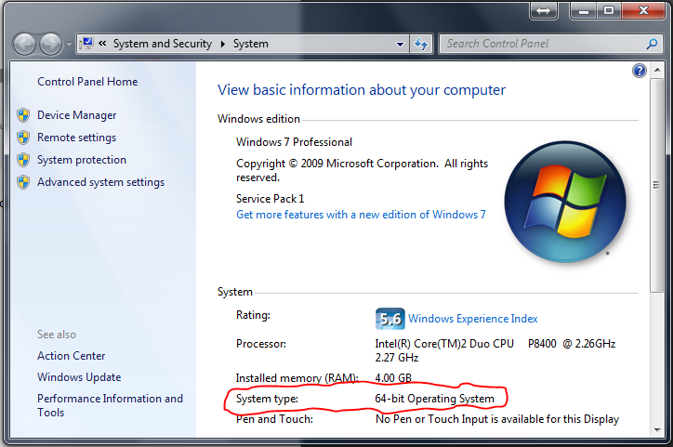

1. Download the P4V: Visual Client.

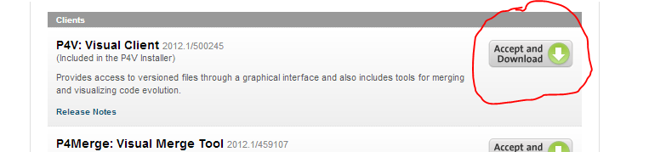

1. Run the installer.
2. Select Features:
   1. You may choose to install the plugin for windows explorer if you’d like, it will add common perforce commands to your explorer context menu so you don’t have to run the gui.
   2. Click Next.

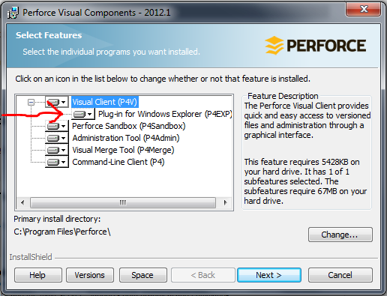

1. Client Configuration
   1. Server: gdserv.fullsail.com:1337
   2. User Name: it should be the first letter of your first name followed by your entire last name all in lower case i.e. for John Smith it would be: jsmith.
   3. Click Next, then click start and wait for the progress bar to finish.

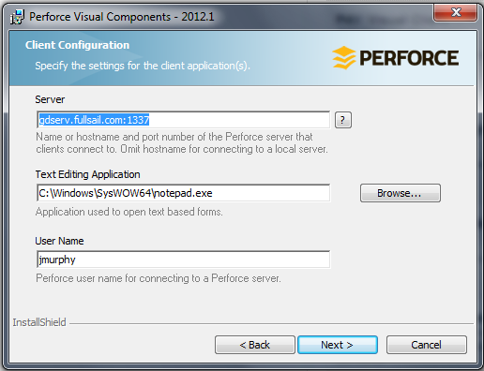

1. Click Finish after it completes.

## Part 2: Setup

1. In you start menu go to Programs->Perforce and open P4V.
2. On the first time it runs it should start with an Open Connection window with the settings filled out from the install server configuration page like this:

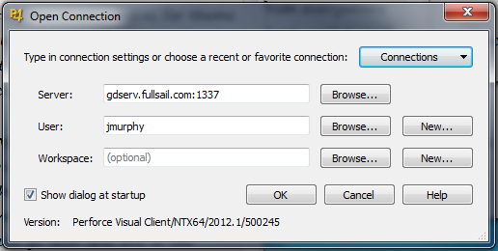

* 1. If you’re not sure your User name is correct click browse an a list should pop up that you can search for and select it using User Name, Email (from day 1 contact list), or Full Name.

1. Create a new workspace (this is where the files will be stored on your computer) if a dialogue pops up asking for a password enter your password, by default it will be “Password” case sensitive
2. A new dialogue window will pop up with several settings for the new work space.
   1. Workspace name: leave this default.
   2. Workspace root: this is the path where the files will be stored. It’s recommended to create a folder called PerforceWork directly on your C drive for quick reference.
   3. Stream: this is for selecting which depot from the server to use. Select browse and there should be a list that pops up (it might take a while cause it has to ping the server) there should be only one stream for you to select.

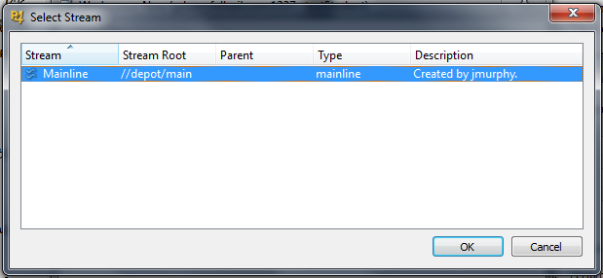

* 1. Click OK.

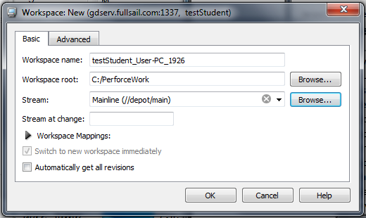

* 1. Click OK again.

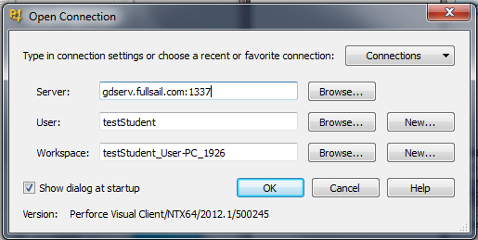

1. Now that a workspace is created you can start working with Perforce. Click OK.
2. You should be presented with a window like this:

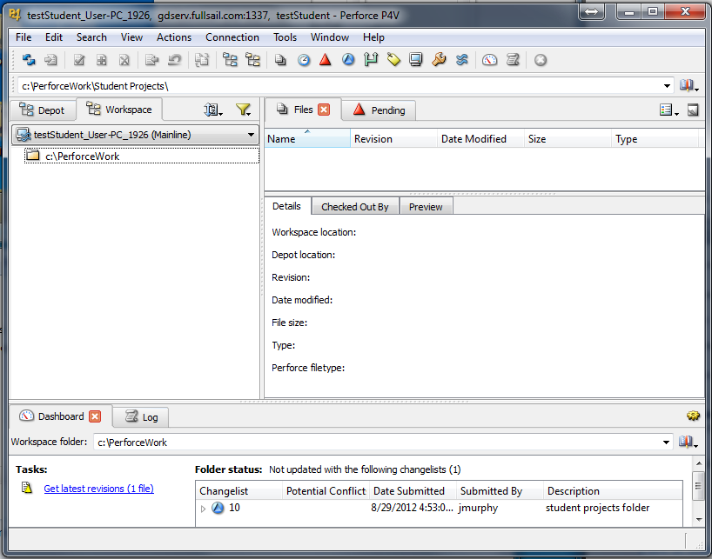

## Part 3: Using Perforce

Now that perforce is installed, connected and a workspace is setup so you can start working. You should change your password so it’s not the generic default password.

1. Change your password:
   1. From the top menu select Connection->Change Password…
   2. Enter your old password, by default it was set to “Password”
   3. Enter a new one following the guidelines listed below the input fields.

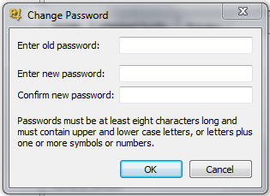

1. Refer to Additional Resources number 2 for an explanation of how to use the perforce client once it has been setup.

## Additional Resources:

1. Getting Started PDF: This explains everything from basic setup to basic use in great detail. <http://www.perforce.com/perforce/doc.current/manuals/p4v-gs/p4v-gs.pdf>
2. Basic SCM Operations in P4V video: This goes over basic source control functionality using the GUI. <http://www.perforce.com/documentation/multimedia_library/tutorials/basic_scm_operations_p4v>
3. P4V Help: Can be accessed by pressing “F1” in the P4V application.
4. Perforce Knowledge Base: <http://kb.perforce.com/> (note: a lot of the online documentation is for the command line client and not for the GUI version.)
5. Other Classmates.
6. Final Project Staff: If you are still having trouble with a part of this tutorial ask someone on Final Project Staff, they should be able to help you out or point you to someone who can.